**DAY 2 ASSIGNMENT**

**QUE:1**

Write the program for deleting an element from the beginning and from any position.

**PROGRAM:**

#include <stdio.h>

#define MAX_SIZE 100

int main()

{

int arr[MAX_SIZE];

int i, size, pos;

/* Input size and element in array */

printf("Enter size of the array : ");

scanf("%d", &size);

printf("Enter elements in array : ");

for(i=0; i<size; i++)

{

scanf("%d", &arr[i]);

}

/* Input element position to delete */

printf("Enter the element position to delete : ");

scanf("%d", &pos);

/* Invalid delete position */

if(pos < 0 || pos > size)

{

printf("Invalid position! Please enter position between 1 to %d", size);

}

else

{

/* Copy next element value to current element */

for(i=pos-1; i<size-1; i++)

{

arr[i] = arr[i + 1];

}

/* Decrement array size by 1 */

size--;

/* Print array after deletion */

printf("\nElements of array after delete are : ");

for(i=0; i<size; i++)

{

printf("%d\t", arr[i]);

}

}

return 0;

}

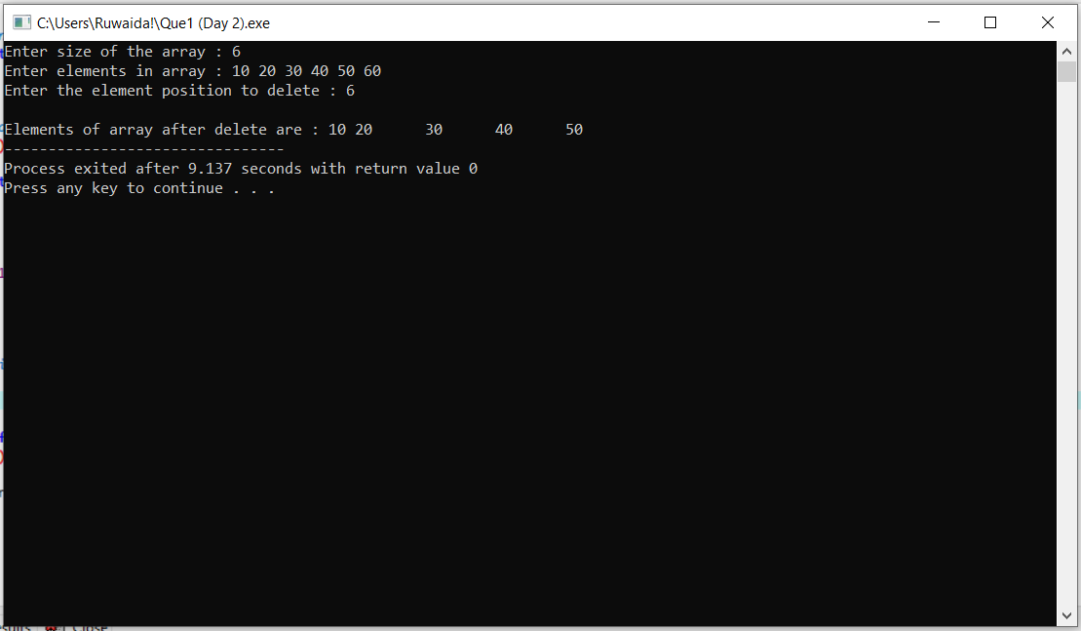

**QUE 2:**

Write the program for printing the array after rotating it k times towards left, where k

would be taken as user input.

**PROGRAM:**

**#**include <conio.h>

int main()

{

int a[10000],i,n,j,k,temp;

printf("Enter size of the array : ");

scanf("%d", &n);

printf("Enter elements in array : ");

for(i=0; i<n; i++)

{

scanf("%d",&a[i]);

}

printf("How many times left rotate : ");

scanf("%d", &k);

for(i=0; i<k; i++)

{

temp=a[0];

for(j=0; j<n-1; j++)

{

a[j]=a[j+1];

}

a[n-1]=temp;

}

printf("\n Array elements after left rotate : ");

for(i=0; i<n; i++)

{

printf("%d ",a[i]);

}

}

